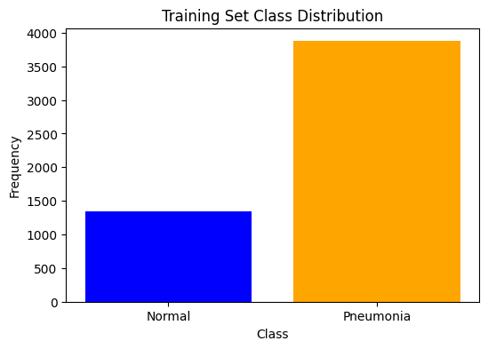
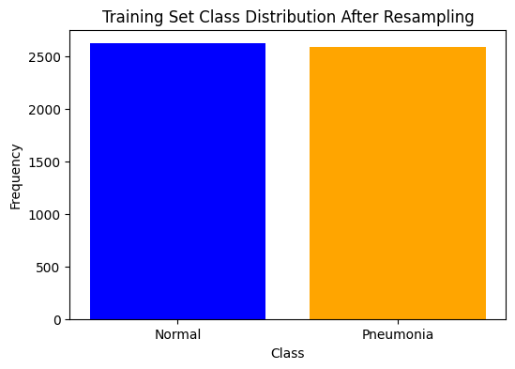
Fold 1/3
----------
Learning_Rate: [0.0001, 0.001]
/opt/conda/lib/python3.10/site-packages/torchvision/models/_utils.py:208: UserWarning: The parameter 'pretrained' is deprecated since 0.13 and may be removed in the future, please use 'weights' instead.
warnings.warn(
/opt/conda/lib/python3.10/site-packages/torchvision/models/_utils.py:223: UserWarning: Arguments other than a weight enum or `None` for 'weights' are deprecated since 0.13 and may be removed in the future. The current behavior is equivalent to passing `weights=ResNet18_Weights.IMAGENET1K_V1`. You can also use `weights=ResNet18_Weights.DEFAULT` to get the most up-to-date weights.
warnings.warn(msg)
Epoch 0/1
----------
Batch 0/109 - Loss: 0.6223422884941101
Batch 10/109 - Loss: 0.5006347894668579
Batch 20/109 - Loss: 0.46167710423469543
Batch 30/109 - Loss: 0.47039252519607544
Batch 40/109 - Loss: 0.5209158658981323
Batch 50/109 - Loss: 0.5160616636276245
Batch 60/109 - Loss: 0.4109746515750885
Batch 70/109 - Loss: 0.3439396023750305
Batch 80/109 - Loss: 0.4628831446170807
Batch 90/109 - Loss: 0.3657134771347046
Batch 100/109 - Loss: 0.3393595516681671
Train Loss: 0.4286 Acc: 0.8056
Epoch 1/1
----------
Batch 0/109 - Loss: 0.3740645945072174
Batch 10/109 - Loss: 0.3171359896659851
Batch 20/109 - Loss: 0.5026761293411255
Batch 30/109 - Loss: 0.2216310352087021
Batch 40/109 - Loss: 0.1972055733203888
Batch 50/109 - Loss: 0.25196006894111633
Batch 60/109 - Loss: 0.22513452172279358
Batch 70/109 - Loss: 0.21421170234680176
Batch 80/109 - Loss: 0.2461969256401062
Batch 90/109 - Loss: 0.23205433785915375
Batch 100/109 - Loss: 0.29859042167663574
Train Loss: 0.2517 Acc: 0.9200
Validation Accuracy: 94.02%
Epoch 0/4
----------
Batch 0/109 - Loss: 0.12315473705530167
Batch 10/109 - Loss: 0.1870933473110199
Batch 20/109 - Loss: 0.2151547372341156
Batch 30/109 - Loss: 0.19302450120449066
Batch 40/109 - Loss: 0.1406758427619934
Batch 50/109 - Loss: 0.13835620880126953
Batch 60/109 - Loss: 0.2410416603088379
Batch 70/109 - Loss: 0.1733284294605255
Batch 80/109 - Loss: 0.24580754339694977
Batch 90/109 - Loss: 0.19588419795036316
Batch 100/109 - Loss: 0.15209448337554932
Train Loss: 0.1898 Acc: 0.9422
Epoch 1/4
----------
Batch 0/109 - Loss: 0.11344479024410248
Batch 10/109 - Loss: 0.17345325648784637
Batch 20/109 - Loss: 0.13857871294021606
Batch 30/109 - Loss: 0.1445208340883255
Batch 40/109 - Loss: 0.14721405506134033
Batch 50/109 - Loss: 0.17316372692584991
Batch 60/109 - Loss: 0.1685471534729004
Batch 70/109 - Loss: 0.17730018496513367
Batch 80/109 - Loss: 0.11044251918792725
Batch 90/109 - Loss: 0.15584757924079895
Batch 100/109 - Loss: 0.0940280556678772
Train Loss: 0.1537 Acc: 0.9523
Epoch 2/4
----------
Batch 0/109 - Loss: 0.09980674088001251
Batch 10/109 - Loss: 0.1268465518951416
Batch 20/109 - Loss: 0.1093728244304657
Batch 30/109 - Loss: 0.10394610464572906
Batch 40/109 - Loss: 0.31461942195892334
Batch 50/109 - Loss: 0.17433062195777893
Batch 60/109 - Loss: 0.09152697026729584
Batch 70/109 - Loss: 0.05141787230968475
Batch 80/109 - Loss: 0.12029056996107101
Batch 90/109 - Loss: 0.06341047585010529
Batch 100/109 - Loss: 0.14267206192016602
Train Loss: 0.1326 Acc: 0.9574
Epoch 3/4
----------
Batch 0/109 - Loss: 0.1859717220067978
Batch 10/109 - Loss: 0.10826228559017181
Batch 20/109 - Loss: 0.16975945234298706
Batch 30/109 - Loss: 0.07996668666601181
Batch 40/109 - Loss: 0.108658567070961
Batch 50/109 - Loss: 0.09859255701303482
Batch 60/109 - Loss: 0.05609434098005295
Batch 70/109 - Loss: 0.12085472047328949
Batch 80/109 - Loss: 0.17980843782424927
Batch 90/109 - Loss: 0.25065523386001587
Batch 100/109 - Loss: 0.0897006243467331
Train Loss: 0.1181 Acc: 0.9646
Epoch 4/4
----------
Batch 0/109 - Loss: 0.08705979585647583
Batch 10/109 - Loss: 0.0916224867105484
Batch 20/109 - Loss: 0.09153859317302704
Batch 30/109 - Loss: 0.1356498897075653
Batch 40/109 - Loss: 0.07151612639427185
Batch 50/109 - Loss: 0.1127835363149643
Batch 60/109 - Loss: 0.04380131512880325
Batch 70/109 - Loss: 0.1076582744717598
Batch 80/109 - Loss: 0.060123179107904434
Batch 90/109 - Loss: 0.06486435979604721
Batch 100/109 - Loss: 0.04532171040773392
Train Loss: 0.1027 Acc: 0.9678
Validation Accuracy: 96.61%
Epoch 0/1
----------
Batch 0/109 - Loss: 0.056414615362882614
Batch 10/109 - Loss: 0.11701995879411697
Batch 20/109 - Loss: 0.06593720614910126
Batch 30/109 - Loss: 0.043430183082818985
Batch 40/109 - Loss: 0.06865284591913223
Batch 50/109 - Loss: 0.026459770277142525
Batch 60/109 - Loss: 0.07074826955795288
Batch 70/109 - Loss: 0.13609209656715393
Batch 80/109 - Loss: 0.07410974055528641
Batch 90/109 - Loss: 0.07269101589918137
Batch 100/109 - Loss: 0.2400781810283661
Train Loss: 0.0824 Acc: 0.9733
Epoch 1/1
----------
Batch 0/109 - Loss: 0.07689505070447922
Batch 10/109 - Loss: 0.12093797326087952
Batch 20/109 - Loss: 0.039178136736154556
Batch 30/109 - Loss: 0.036184340715408325
Batch 40/109 - Loss: 0.050779789686203
Batch 50/109 - Loss: 0.07904604822397232
Batch 60/109 - Loss: 0.009095842018723488
Batch 70/109 - Loss: 0.035915058106184006
Batch 80/109 - Loss: 0.05001388490200043
Batch 90/109 - Loss: 0.025309331715106964
Batch 100/109 - Loss: 0.04475197196006775
Train Loss: 0.0485 Acc: 0.9848
Validation Accuracy: 98.39%
Epoch 0/4
----------
Batch 0/109 - Loss: 0.031015653163194656
Batch 10/109 - Loss: 0.008348104543983936
Batch 20/109 - Loss: 0.04992370307445526
Batch 30/109 - Loss: 0.014484414830803871
Batch 40/109 - Loss: 0.0336076021194458
Batch 50/109 - Loss: 0.007288786582648754
Batch 60/109 - Loss: 0.006177112460136414
Batch 70/109 - Loss: 0.03373751789331436
Batch 80/109 - Loss: 0.013134803622961044
Batch 90/109 - Loss: 0.005865886341780424
Batch 100/109 - Loss: 0.006669109687209129
Train Loss: 0.0273 Acc: 0.9934
Epoch 1/4
----------
Batch 0/109 - Loss: 0.028633618727326393
Batch 10/109 - Loss: 0.015296160243451595
Batch 20/109 - Loss: 0.008184129372239113
Batch 30/109 - Loss: 0.0024079661816358566
Batch 40/109 - Loss: 0.025137025862932205
Batch 50/109 - Loss: 0.012955006211996078
Batch 60/109 - Loss: 0.00638773525133729
Batch 70/109 - Loss: 0.00868259184062481
Batch 80/109 - Loss: 0.0363374687731266
Batch 90/109 - Loss: 0.01500561274588108
Batch 100/109 - Loss: 0.004911544732749462
Train Loss: 0.0195 Acc: 0.9963
Epoch 2/4
----------
Batch 0/109 - Loss: 0.004733908921480179
Batch 10/109 - Loss: 0.018481560051441193
Batch 20/109 - Loss: 0.0037746112793684006
Batch 30/109 - Loss: 0.005035375710576773
Batch 40/109 - Loss: 0.008451497182250023
Batch 50/109 - Loss: 0.004735682625323534
Batch 60/109 - Loss: 0.015504993498325348
Batch 70/109 - Loss: 0.035193830728530884
Batch 80/109 - Loss: 0.005675300024449825
Batch 90/109 - Loss: 0.013432402163743973
Batch 100/109 - Loss: 0.006008462514728308
Train Loss: 0.0100 Acc: 0.9991
Epoch 3/4
----------
Batch 0/109 - Loss: 0.005415932275354862
Batch 10/109 - Loss: 0.025091437622904778
Batch 20/109 - Loss: 0.011372774839401245
Batch 30/109 - Loss: 0.003263067686930299
Batch 40/109 - Loss: 0.007048474624752998
Batch 50/109 - Loss: 0.0011161137372255325
Batch 60/109 - Loss: 0.013072922825813293
Batch 70/109 - Loss: 0.02836032398045063
Batch 80/109 - Loss: 0.0024420241825282574
Batch 90/109 - Loss: 0.001462911139242351
Batch 100/109 - Loss: 0.013267298229038715
Train Loss: 0.0102 Acc: 0.9994
Epoch 4/4
----------
Batch 0/109 - Loss: 0.0028311004862189293
Batch 10/109 - Loss: 0.006390604190528393
Batch 20/109 - Loss: 0.011031811125576496
Batch 30/109 - Loss: 0.016495132818818092
Batch 40/109 - Loss: 0.002065046690404415
Batch 50/109 - Loss: 0.0014444306725636125
Batch 60/109 - Loss: 0.007789237424731255
Batch 70/109 - Loss: 0.0018872780492529273
Batch 80/109 - Loss: 0.002588990144431591
Batch 90/109 - Loss: 0.000357642158633098
Batch 100/109 - Loss: 0.014642615802586079
Train Loss: 0.0056 Acc: 1.0000
Validation Accuracy: 98.79%
Best hyperparameters for fold 1: {'learning_rate': 0.001, 'num_epochs': 5}
Epoch 0/4
----------
Batch 0/109 - Loss: 0.0005901032709516585
Batch 10/109 - Loss: 0.007631529122591019
Batch 20/109 - Loss: 0.0013696900568902493
Batch 30/109 - Loss: 0.018517794087529182
Batch 40/109 - Loss: 0.0029108147136867046
Batch 50/109 - Loss: 0.0013928909320384264
Batch 60/109 - Loss: 0.0008617133134976029
Batch 70/109 - Loss: 0.0008655564161017537
Batch 80/109 - Loss: 0.0034364706370979548
Batch 90/109 - Loss: 0.003681889967992902
Batch 100/109 - Loss: 0.002291976474225521
Train Loss: 0.0046 Acc: 0.9997
Epoch 1/4
----------
Batch 0/109 - Loss: 0.0028572934679687023
Batch 10/109 - Loss: 0.0016321588773280382
Batch 20/109 - Loss: 0.0029143295250833035
Batch 30/109 - Loss: 0.0018917866982519627
Batch 40/109 - Loss: 0.012208227068185806
Batch 50/109 - Loss: 0.0045922063291072845
Batch 60/109 - Loss: 0.002484709955751896
Batch 70/109 - Loss: 0.0013420266332104802
Batch 80/109 - Loss: 0.0010222955606877804
Batch 90/109 - Loss: 0.008376660756766796
Batch 100/109 - Loss: 0.0006056408165022731
Train Loss: 0.0053 Acc: 0.9994
Epoch 2/4
----------
Batch 0/109 - Loss: 0.0011192115489393473
Batch 10/109 - Loss: 0.0007876282325014472
Batch 20/109 - Loss: 0.002639075042679906
Batch 30/109 - Loss: 0.002703580306842923
Batch 40/109 - Loss: 0.0011087439488619566
Batch 50/109 - Loss: 0.002385146450251341
Batch 60/109 - Loss: 0.0018493764800950885
Batch 70/109 - Loss: 0.00031152996234595776
Batch 80/109 - Loss: 0.00779259018599987
Batch 90/109 - Loss: 0.001861073076725006
Batch 100/109 - Loss: 0.0024037682451307774
Train Loss: 0.0053 Acc: 0.9991
Epoch 3/4
----------
Batch 0/109 - Loss: 0.0018820773111656308
Batch 10/109 - Loss: 0.0029691325034946203
Batch 20/109 - Loss: 0.0013275033561512828
Batch 30/109 - Loss: 0.0035841770004481077
Batch 40/109 - Loss: 0.0020693012047559023
Batch 50/109 - Loss: 0.0028204384725540876
Batch 60/109 - Loss: 0.0007630566251464188
Batch 70/109 - Loss: 0.00037400980363599956
Batch 80/109 - Loss: 0.0008681838517077267
Batch 90/109 - Loss: 0.0006417867261916399
Batch 100/109 - Loss: 0.004366428125649691
Train Loss: 0.0024 Acc: 1.0000
Epoch 4/4
----------
Batch 0/109 - Loss: 0.0024905321188271046
Batch 10/109 - Loss: 0.001059275702573359
Batch 20/109 - Loss: 0.0011880692327395082
Batch 30/109 - Loss: 0.008784279227256775
Batch 40/109 - Loss: 0.0020253369584679604
Batch 50/109 - Loss: 0.0027580764144659042
Batch 60/109 - Loss: 0.00927681103348732
Batch 70/109 - Loss: 0.0010613705962896347
Batch 80/109 - Loss: 0.0004440397606231272
Batch 90/109 - Loss: 0.0005118588451296091
Batch 100/109 - Loss: 0.0005998352426104248
Train Loss: 0.0058 Acc: 0.9991
Validation Accuracy: 98.73%
Fold 2/3
----------
Learning_Rate: [0.0001, 0.001]
/opt/conda/lib/python3.10/site-packages/torchvision/models/_utils.py:208: UserWarning: The parameter 'pretrained' is deprecated since 0.13 and may be removed in the future, please use 'weights' instead.
warnings.warn(
/opt/conda/lib/python3.10/site-packages/torchvision/models/_utils.py:223: UserWarning: Arguments other than a weight enum or `None` for 'weights' are deprecated since 0.13 and may be removed in the future. The current behavior is equivalent to passing `weights=ResNet18_Weights.IMAGENET1K_V1`. You can also use `weights=ResNet18_Weights.DEFAULT` to get the most up-to-date weights.
warnings.warn(msg)
Epoch 0/1
----------
Batch 0/109 - Loss: 0.7049057483673096
Batch 10/109 - Loss: 0.6168540716171265
Batch 20/109 - Loss: 0.6007068157196045
Batch 30/109 - Loss: 0.5944893956184387
Batch 40/109 - Loss: 0.4119212031364441
Batch 50/109 - Loss: 0.39210015535354614
Batch 60/109 - Loss: 0.44302988052368164
Batch 70/109 - Loss: 0.40590375661849976
Batch 80/109 - Loss: 0.3667163848876953
Batch 90/109 - Loss: 0.3752009868621826
Batch 100/109 - Loss: 0.3340868353843689
Train Loss: 0.4558 Acc: 0.7725
Epoch 1/1
----------
Batch 0/109 - Loss: 0.2627996504306793
Batch 10/109 - Loss: 0.2707862854003906
Batch 20/109 - Loss: 0.24238403141498566
Batch 30/109 - Loss: 0.22568023204803467
Batch 40/109 - Loss: 0.3048328757286072
Batch 50/109 - Loss: 0.3737349212169647
Batch 60/109 - Loss: 0.2268502414226532
Batch 70/109 - Loss: 0.2296081781387329
Batch 80/109 - Loss: 0.2926197350025177
Batch 90/109 - Loss: 0.24161013960838318
Batch 100/109 - Loss: 0.23036357760429382
Train Loss: 0.2623 Acc: 0.9180
Validation Accuracy: 95.34%
Epoch 0/4
----------
Batch 0/109 - Loss: 0.21778059005737305
Batch 10/109 - Loss: 0.2683016359806061
Batch 20/109 - Loss: 0.23285678029060364
Batch 30/109 - Loss: 0.25272855162620544
Batch 40/109 - Loss: 0.20490619540214539
Batch 50/109 - Loss: 0.23879767954349518
Batch 60/109 - Loss: 0.25052881240844727
Batch 70/109 - Loss: 0.20836380124092102
Batch 80/109 - Loss: 0.18051038682460785
Batch 90/109 - Loss: 0.13429021835327148
Batch 100/109 - Loss: 0.15683990716934204
Train Loss: 0.1938 Acc: 0.9482
Epoch 1/4
----------
Batch 0/109 - Loss: 0.17863598465919495
Batch 10/109 - Loss: 0.21798349916934967
Batch 20/109 - Loss: 0.19313280284404755
Batch 30/109 - Loss: 0.1304248571395874
Batch 40/109 - Loss: 0.10601267963647842
Batch 50/109 - Loss: 0.20067459344863892
Batch 60/109 - Loss: 0.10913393646478653
Batch 70/109 - Loss: 0.09941691160202026
Batch 80/109 - Loss: 0.13112583756446838
Batch 90/109 - Loss: 0.1592569351196289
Batch 100/109 - Loss: 0.14494343101978302
Train Loss: 0.1629 Acc: 0.9531
Epoch 2/4
----------
Batch 0/109 - Loss: 0.284870982170105
Batch 10/109 - Loss: 0.11662205308675766
Batch 20/109 - Loss: 0.23247025907039642
Batch 30/109 - Loss: 0.12005272507667542
Batch 40/109 - Loss: 0.23380112648010254
Batch 50/109 - Loss: 0.18319249153137207
Batch 60/109 - Loss: 0.09204529225826263
Batch 70/109 - Loss: 0.13476206362247467
Batch 80/109 - Loss: 0.12570275366306305
Batch 90/109 - Loss: 0.18308529257774353
Batch 100/109 - Loss: 0.24370595812797546
Train Loss: 0.1387 Acc: 0.9592
Epoch 3/4
----------
Batch 0/109 - Loss: 0.07747385650873184
Batch 10/109 - Loss: 0.0831872969865799
Batch 20/109 - Loss: 0.07617579400539398
Batch 30/109 - Loss: 0.15359683334827423
Batch 40/109 - Loss: 0.13554084300994873
Batch 50/109 - Loss: 0.16493970155715942
Batch 60/109 - Loss: 0.08008390665054321
Batch 70/109 - Loss: 0.06741279363632202
Batch 80/109 - Loss: 0.10770265758037567
Batch 90/109 - Loss: 0.0638355240225792
Batch 100/109 - Loss: 0.17696833610534668
Train Loss: 0.1232 Acc: 0.9638
Epoch 4/4
----------
Batch 0/109 - Loss: 0.11296026408672333
Batch 10/109 - Loss: 0.08246327191591263
Batch 20/109 - Loss: 0.10985009372234344
Batch 30/109 - Loss: 0.0787937268614769
Batch 40/109 - Loss: 0.0986848771572113
Batch 50/109 - Loss: 0.11669263988733292
Batch 60/109 - Loss: 0.14069518446922302
Batch 70/109 - Loss: 0.10302885621786118
Batch 80/109 - Loss: 0.04120372235774994
Batch 90/109 - Loss: 0.0641716867685318
Batch 100/109 - Loss: 0.10940384864807129
Train Loss: 0.1034 Acc: 0.9715
Validation Accuracy: 97.41%
Epoch 0/1
----------
Batch 0/109 - Loss: 0.06247521936893463
Batch 10/109 - Loss: 0.04221760481595993
Batch 20/109 - Loss: 0.09915708005428314
Batch 30/109 - Loss: 0.040101997554302216
Batch 40/109 - Loss: 0.08284428715705872
Batch 50/109 - Loss: 0.08800441771745682
Batch 60/109 - Loss: 0.10700906813144684
Batch 70/109 - Loss: 0.052738770842552185
Batch 80/109 - Loss: 0.06067365035414696
Batch 90/109 - Loss: 0.10215727984905243
Batch 100/109 - Loss: 0.053275421261787415
Train Loss: 0.0893 Acc: 0.9689
Epoch 1/1
----------
Batch 0/109 - Loss: 0.09582579135894775
Batch 10/109 - Loss: 0.014942970126867294
Batch 20/109 - Loss: 0.023937590420246124
Batch 30/109 - Loss: 0.03468189388513565
Batch 40/109 - Loss: 0.008450769819319248
Batch 50/109 - Loss: 0.029653435572981834
Batch 60/109 - Loss: 0.015379475429654121
Batch 70/109 - Loss: 0.1352740377187729
Batch 80/109 - Loss: 0.01915859989821911
Batch 90/109 - Loss: 0.049309730529785156
Batch 100/109 - Loss: 0.027988696470856667
Train Loss: 0.0512 Acc: 0.9830
Validation Accuracy: 98.33%
Epoch 0/4
----------
Batch 0/109 - Loss: 0.035649508237838745
Batch 10/109 - Loss: 0.08254576474428177
Batch 20/109 - Loss: 0.00740305008366704
Batch 30/109 - Loss: 0.013325389474630356
Batch 40/109 - Loss: 0.030479848384857178
Batch 50/109 - Loss: 0.010136299766600132
Batch 60/109 - Loss: 0.008814352564513683
Batch 70/109 - Loss: 0.0036340015940368176
Batch 80/109 - Loss: 0.02210281230509281
Batch 90/109 - Loss: 0.015351896174252033
Batch 100/109 - Loss: 0.026131071150302887
Train Loss: 0.0319 Acc: 0.9905
Epoch 1/4
----------
Batch 0/109 - Loss: 0.018020713701844215
Batch 10/109 - Loss: 0.020893558859825134
Batch 20/109 - Loss: 0.20936737954616547
Batch 30/109 - Loss: 0.017966769635677338
Batch 40/109 - Loss: 0.009043673984706402
Batch 50/109 - Loss: 0.04294494912028313
Batch 60/109 - Loss: 0.008279761299490929
Batch 70/109 - Loss: 0.005731166340410709
Batch 80/109 - Loss: 0.21093621850013733
Batch 90/109 - Loss: 0.016260089352726936
Batch 100/109 - Loss: 0.013976695016026497
Train Loss: 0.0225 Acc: 0.9934
Epoch 2/4
----------
Batch 0/109 - Loss: 0.006136673036962748
Batch 10/109 - Loss: 0.013510117307305336
Batch 20/109 - Loss: 0.01743973419070244
Batch 30/109 - Loss: 0.0058663045056164265
Batch 40/109 - Loss: 0.004429277498275042
Batch 50/109 - Loss: 0.0052551887929439545
Batch 60/109 - Loss: 0.008730839937925339
Batch 70/109 - Loss: 0.010949079878628254
Batch 80/109 - Loss: 0.00656196940690279
Batch 90/109 - Loss: 0.0017788062104955316
Batch 100/109 - Loss: 0.005970997270196676
Train Loss: 0.0122 Acc: 0.9983
Epoch 3/4
----------
Batch 0/109 - Loss: 0.06111530214548111
Batch 10/109 - Loss: 0.0050999876111745834
Batch 20/109 - Loss: 0.0017222421010956168
Batch 30/109 - Loss: 0.0027372194454073906
Batch 40/109 - Loss: 0.006674336269497871
Batch 50/109 - Loss: 0.0013166870921850204
Batch 60/109 - Loss: 0.0014628540957346559
Batch 70/109 - Loss: 0.05293429642915726
Batch 80/109 - Loss: 0.005408581346273422
Batch 90/109 - Loss: 0.0038820593617856503
Batch 100/109 - Loss: 0.004627387970685959
Train Loss: 0.0110 Acc: 0.9974
Epoch 4/4
----------
Batch 0/109 - Loss: 0.004989602603018284
Batch 10/109 - Loss: 0.07421985268592834
Batch 20/109 - Loss: 0.00452357716858387
Batch 30/109 - Loss: 0.00882130116224289
Batch 40/109 - Loss: 0.00472184969112277
Batch 50/109 - Loss: 0.004060325678437948
Batch 60/109 - Loss: 0.0031098928302526474
Batch 70/109 - Loss: 0.035283543169498444
Batch 80/109 - Loss: 0.0033805319108068943
Batch 90/109 - Loss: 0.007032876834273338
Batch 100/109 - Loss: 0.0028019212186336517
Train Loss: 0.0083 Acc: 0.9977
Validation Accuracy: 98.91%
Best hyperparameters for fold 2: {'learning_rate': 0.001, 'num_epochs': 5}
Epoch 0/4
----------
Batch 0/109 - Loss: 0.003146515227854252
Batch 10/109 - Loss: 0.014752043411135674
Batch 20/109 - Loss: 0.009181244298815727
Batch 30/109 - Loss: 0.00212659128010273
Batch 40/109 - Loss: 0.0031872675754129887
Batch 50/109 - Loss: 0.007011586334556341
Batch 60/109 - Loss: 0.0102941133081913
Batch 70/109 - Loss: 0.0040398468263447285
Batch 80/109 - Loss: 0.004347127862274647
Batch 90/109 - Loss: 0.002887972630560398
Batch 100/109 - Loss: 0.0012847254984080791
Train Loss: 0.0074 Acc: 0.9980
Epoch 1/4
----------
Batch 0/109 - Loss: 0.004931124392896891
Batch 10/109 - Loss: 0.0008772918954491615
Batch 20/109 - Loss: 0.002963543403893709
Batch 30/109 - Loss: 0.0021953945979475975
Batch 40/109 - Loss: 0.0027643516659736633
Batch 50/109 - Loss: 0.0025216504000127316
Batch 60/109 - Loss: 0.0006218765047378838
Batch 70/109 - Loss: 0.0011086339363828301
Batch 80/109 - Loss: 0.005889600608497858
Batch 90/109 - Loss: 0.0017393375746905804
Batch 100/109 - Loss: 0.0018523195758461952
Train Loss: 0.0041 Acc: 1.0000
Epoch 2/4
----------
Batch 0/109 - Loss: 0.0010325786424800754
Batch 10/109 - Loss: 0.001559918513521552
Batch 20/109 - Loss: 0.0009547605877742171
Batch 30/109 - Loss: 0.0049337176606059074
Batch 40/109 - Loss: 0.001161049003712833
Batch 50/109 - Loss: 0.0153532475233078
Batch 60/109 - Loss: 0.005688777193427086
Batch 70/109 - Loss: 0.003004180733114481
Batch 80/109 - Loss: 0.001237905933521688
Batch 90/109 - Loss: 0.02967779152095318
Batch 100/109 - Loss: 0.017180660739541054
Train Loss: 0.0045 Acc: 1.0000
Epoch 3/4
----------
Batch 0/109 - Loss: 0.0013023994397372007
Batch 10/109 - Loss: 0.0022562758531421423
Batch 20/109 - Loss: 0.0012629261473193765
Batch 30/109 - Loss: 0.0016128092538565397
Batch 40/109 - Loss: 0.01093003898859024
Batch 50/109 - Loss: 0.0006691503804177046
Batch 60/109 - Loss: 0.0006752659101039171
Batch 70/109 - Loss: 0.00416359631344676
Batch 80/109 - Loss: 0.001977012027055025
Batch 90/109 - Loss: 0.006512779742479324
Batch 100/109 - Loss: 0.0035514039918780327
Train Loss: 0.0028 Acc: 1.0000
Epoch 4/4
----------
Batch 0/109 - Loss: 0.0005552397924475372
Batch 10/109 - Loss: 0.0036186054348945618
Batch 20/109 - Loss: 0.0007124484982341528
Batch 30/109 - Loss: 0.0017183785093948245
Batch 40/109 - Loss: 0.001505293999798596
Batch 50/109 - Loss: 0.004242921248078346
Batch 60/109 - Loss: 0.0008680610335431993
Batch 70/109 - Loss: 0.0030753365717828274
Batch 80/109 - Loss: 0.0007674936205148697
Batch 90/109 - Loss: 0.0009531630203127861
Batch 100/109 - Loss: 0.004926078021526337
Train Loss: 0.0037 Acc: 0.9997
Validation Accuracy: 98.96%
Fold 3/3
----------
Learning_Rate: [0.0001, 0.001]
/opt/conda/lib/python3.10/site-packages/torchvision/models/_utils.py:208: UserWarning: The parameter 'pretrained' is deprecated since 0.13 and may be removed in the future, please use 'weights' instead.
warnings.warn(
/opt/conda/lib/python3.10/site-packages/torchvision/models/_utils.py:223: UserWarning: Arguments other than a weight enum or `None` for 'weights' are deprecated since 0.13 and may be removed in the future. The current behavior is equivalent to passing `weights=ResNet18_Weights.IMAGENET1K_V1`. You can also use `weights=ResNet18_Weights.DEFAULT` to get the most up-to-date weights.
warnings.warn(msg)
Epoch 0/1
----------
Batch 0/109 - Loss: 0.8147835731506348
Batch 10/109 - Loss: 0.6317460536956787
Batch 20/109 - Loss: 0.5092483162879944
Batch 30/109 - Loss: 0.3784746527671814
Batch 40/109 - Loss: 0.4709932804107666
Batch 50/109 - Loss: 0.6974598169326782
Batch 60/109 - Loss: 0.3827950954437256
Batch 70/109 - Loss: 0.3893682360649109
Batch 80/109 - Loss: 0.3055363595485687
Batch 90/109 - Loss: 0.32973241806030273
Batch 100/109 - Loss: 0.3217616081237793
Train Loss: 0.4378 Acc: 0.7795
Epoch 1/1
----------
Batch 0/109 - Loss: 0.3727112114429474
Batch 10/109 - Loss: 0.22766992449760437
Batch 20/109 - Loss: 0.23261651396751404
Batch 30/109 - Loss: 0.2367572784423828
Batch 40/109 - Loss: 0.22755710780620575
Batch 50/109 - Loss: 0.3052125573158264
Batch 60/109 - Loss: 0.1502004861831665
Batch 70/109 - Loss: 0.16790974140167236
Batch 80/109 - Loss: 0.21683627367019653
Batch 90/109 - Loss: 0.23785626888275146
Batch 100/109 - Loss: 0.27463698387145996
Train Loss: 0.2378 Acc: 0.9319
Validation Accuracy: 93.90%
Epoch 0/4
----------
Batch 0/109 - Loss: 0.2422073930501938
Batch 10/109 - Loss: 0.18569554388523102
Batch 20/109 - Loss: 0.15388810634613037
Batch 30/109 - Loss: 0.2590970993041992
Batch 40/109 - Loss: 0.18757383525371552
Batch 50/109 - Loss: 0.17127244174480438
Batch 60/109 - Loss: 0.19254666566848755
Batch 70/109 - Loss: 0.2430146336555481
Batch 80/109 - Loss: 0.2441396266222
Batch 90/109 - Loss: 0.12828420102596283
Batch 100/109 - Loss: 0.1885828822851181
Train Loss: 0.1893 Acc: 0.9385
Epoch 1/4
----------
Batch 0/109 - Loss: 0.24495840072631836
Batch 10/109 - Loss: 0.18466022610664368
Batch 20/109 - Loss: 0.12927909195423126
Batch 30/109 - Loss: 0.13641327619552612
Batch 40/109 - Loss: 0.16364435851573944
Batch 50/109 - Loss: 0.12319973111152649
Batch 60/109 - Loss: 0.10432253032922745
Batch 70/109 - Loss: 0.13351577520370483
Batch 80/109 - Loss: 0.0993475466966629
Batch 90/109 - Loss: 0.15585854649543762
Batch 100/109 - Loss: 0.27820417284965515
Train Loss: 0.1474 Acc: 0.9546
Epoch 2/4
----------
Batch 0/109 - Loss: 0.10050307214260101
Batch 10/109 - Loss: 0.06073770299553871
Batch 20/109 - Loss: 0.17954619228839874
Batch 30/109 - Loss: 0.10647013783454895
Batch 40/109 - Loss: 0.1657513529062271
Batch 50/109 - Loss: 0.09818167984485626
Batch 60/109 - Loss: 0.08785708993673325
Batch 70/109 - Loss: 0.10090882331132889
Batch 80/109 - Loss: 0.19085563719272614
Batch 90/109 - Loss: 0.08211593329906464
Batch 100/109 - Loss: 0.14568132162094116
Train Loss: 0.1257 Acc: 0.9597
Epoch 3/4
----------
Batch 0/109 - Loss: 0.07259995490312576
Batch 10/109 - Loss: 0.11479051411151886
Batch 20/109 - Loss: 0.12484676390886307
Batch 30/109 - Loss: 0.09095506370067596
Batch 40/109 - Loss: 0.08113827556371689
Batch 50/109 - Loss: 0.132786363363266
Batch 60/109 - Loss: 0.17565229535102844
Batch 70/109 - Loss: 0.10358529537916183
Batch 80/109 - Loss: 0.11555957794189453
Batch 90/109 - Loss: 0.11720366030931473
Batch 100/109 - Loss: 0.099675253033638
Train Loss: 0.1133 Acc: 0.9655
Epoch 4/4
----------
Batch 0/109 - Loss: 0.0556318573653698
Batch 10/109 - Loss: 0.11210460960865021
Batch 20/109 - Loss: 0.029576146975159645
Batch 30/109 - Loss: 0.05953757464885712
Batch 40/109 - Loss: 0.07749681174755096
Batch 50/109 - Loss: 0.03815596550703049
Batch 60/109 - Loss: 0.07390706986188889
Batch 70/109 - Loss: 0.13042746484279633
Batch 80/109 - Loss: 0.04659601300954819
Batch 90/109 - Loss: 0.07763268798589706
Batch 100/109 - Loss: 0.07667075097560883
Train Loss: 0.1027 Acc: 0.9715
Validation Accuracy: 96.09%
Epoch 0/1
----------
Batch 0/109 - Loss: 0.08055940270423889
Batch 10/109 - Loss: 0.07565252482891083
Batch 20/109 - Loss: 0.10963866114616394
Batch 30/109 - Loss: 0.05910668894648552
Batch 40/109 - Loss: 0.16146023571491241
Batch 50/109 - Loss: 0.03661246597766876
Batch 60/109 - Loss: 0.11655555665493011
Batch 70/109 - Loss: 0.12834547460079193
Batch 80/109 - Loss: 0.029568087309598923
Batch 90/109 - Loss: 0.09141920506954193
Batch 100/109 - Loss: 0.022924024611711502
Train Loss: 0.0885 Acc: 0.9712
Epoch 1/1
----------
Batch 0/109 - Loss: 0.04480624571442604
Batch 10/109 - Loss: 0.07838322222232819
Batch 20/109 - Loss: 0.02781911939382553
Batch 30/109 - Loss: 0.03393474593758583
Batch 40/109 - Loss: 0.028985686600208282
Batch 50/109 - Loss: 0.06272445619106293
Batch 60/109 - Loss: 0.019697263836860657
Batch 70/109 - Loss: 0.1355142891407013
Batch 80/109 - Loss: 0.07054619491100311
Batch 90/109 - Loss: 0.019316446036100388
Batch 100/109 - Loss: 0.024811184033751488
Train Loss: 0.0496 Acc: 0.9848
Validation Accuracy: 97.64%
Epoch 0/4
----------
Batch 0/109 - Loss: 0.045481957495212555
Batch 10/109 - Loss: 0.019940830767154694
Batch 20/109 - Loss: 0.0711391493678093
Batch 30/109 - Loss: 0.004605662077665329
Batch 40/109 - Loss: 0.017541266977787018
Batch 50/109 - Loss: 0.0294045377522707
Batch 60/109 - Loss: 0.06850355863571167
Batch 70/109 - Loss: 0.06642674654722214
Batch 80/109 - Loss: 0.010911070741713047
Batch 90/109 - Loss: 0.06350675225257874
Batch 100/109 - Loss: 0.03515149652957916
Train Loss: 0.0301 Acc: 0.9934
Epoch 1/4
----------
Batch 0/109 - Loss: 0.006853695027530193
Batch 10/109 - Loss: 0.009729234501719475
Batch 20/109 - Loss: 0.03289088234305382
Batch 30/109 - Loss: 0.004714134614914656
Batch 40/109 - Loss: 0.0067587075755000114
Batch 50/109 - Loss: 0.016159409657120705
Batch 60/109 - Loss: 0.003001952078193426
Batch 70/109 - Loss: 0.007994922809302807
Batch 80/109 - Loss: 0.02097482606768608
Batch 90/109 - Loss: 0.06703484803438187
Batch 100/109 - Loss: 0.03038136661052704
Train Loss: 0.0240 Acc: 0.9934
Epoch 2/4
----------
Batch 0/109 - Loss: 0.005044655874371529
Batch 10/109 - Loss: 0.003093304578214884
Batch 20/109 - Loss: 0.003870920278131962
Batch 30/109 - Loss: 0.0027202756609767675
Batch 40/109 - Loss: 0.0023753459099680185
Batch 50/109 - Loss: 0.012805759906768799
Batch 60/109 - Loss: 0.004414835013449192
Batch 70/109 - Loss: 0.0027283199597150087
Batch 80/109 - Loss: 0.00848875381052494
Batch 90/109 - Loss: 0.006920660845935345
Batch 100/109 - Loss: 0.006638423074036837
Batch 40/109 - Loss: 0.022009603679180145
Batch 50/109 - Loss: 0.0036277843173593283
Batch 60/109 - Loss: 0.002488783560693264
Batch 70/109 - Loss: 0.005045648664236069
Batch 80/109 - Loss: 0.04421177878975868
Batch 90/109 - Loss: 0.01473701000213623
Batch 100/109 - Loss: 0.002216898836195469
Train Loss: 0.0097 Acc: 0.9983
Epoch 4/4
----------
Batch 0/109 - Loss: 0.0032284872140735388
Batch 10/109 - Loss: 0.009252432733774185
Batch 20/109 - Loss: 0.00615548575296998
Batch 30/109 - Loss: 0.016961153596639633
Batch 40/109 - Loss: 0.005850651301443577
Batch 50/109 - Loss: 0.0018119480228051543
Batch 60/109 - Loss: 0.0007384121417999268
Batch 70/109 - Loss: 0.0014882631367072463
Batch 80/109 - Loss: 0.023918066173791885
Batch 90/109 - Loss: 0.015793772414326668
Batch 100/109 - Loss: 0.0026947748847305775
Train Loss: 0.0068 Acc: 0.9994
Validation Accuracy: 98.22%
Best hyperparameters for fold 3: {'learning_rate': 0.001, 'num_epochs': 5}
Epoch 0/4
----------
Batch 0/109 - Loss: 0.002728740219026804
Batch 10/109 - Loss: 0.0028748060576617718
Batch 20/109 - Loss: 0.0009581121266819537
Batch 30/109 - Loss: 0.012188762426376343
Batch 40/109 - Loss: 0.011923972517251968
Batch 50/109 - Loss: 0.0016811627428978682
Batch 60/109 - Loss: 0.0015276004560291767
Batch 70/109 - Loss: 0.005901195574551821
Batch 80/109 - Loss: 0.0008464802522212267
Batch 90/109 - Loss: 0.0019495112355798483
Batch 100/109 - Loss: 0.00235241511836648
Batch 60/109 - Loss: 0.0009007411426864564
Batch 70/109 - Loss: 0.0008146606851369143
Batch 80/109 - Loss: 0.0009498494910076261
Batch 90/109 - Loss: 0.000682648504152894
Batch 100/109 - Loss: 0.0014800068456679583
Train Loss: 0.0033 Acc: 0.9997
Epoch 3/4
----------
Batch 0/109 - Loss: 0.001449566800147295
Batch 10/109 - Loss: 0.001307956874370575
Batch 20/109 - Loss: 0.0004547362623270601
Batch 30/109 - Loss: 0.0007848953828215599
Batch 40/109 - Loss: 0.00030685015372000635
Batch 50/109 - Loss: 0.0011907161679118872
Batch 60/109 - Loss: 0.00359474029392004
Batch 70/109 - Loss: 0.0011286837980151176
Batch 80/109 - Loss: 0.0008282434428110719
Batch 90/109 - Loss: 0.0017597103724256158
Batch 100/109 - Loss: 0.0008834497421048582
Train Loss: 0.0028 Acc: 1.0000
Epoch 4/4
----------
Batch 0/109 - Loss: 0.0025797646958380938
Batch 10/109 - Loss: 0.0009098133305087686
Batch 20/109 - Loss: 0.024006210267543793
Batch 30/109 - Loss: 0.0006054029799997807
Batch 40/109 - Loss: 0.0011663992190733552
Batch 50/109 - Loss: 0.0008608814678154886
Batch 60/109 - Loss: 0.001567736268043518
Batch 70/109 - Loss: 0.0017658050637692213
Batch 80/109 - Loss: 0.0007613545749336481
Batch 90/109 - Loss: 0.0011429551523178816
Batch 100/109 - Loss: 0.005058853421360254
Train Loss: 0.0023 Acc: 1.0000
Validation Accuracy: 98.10%
Average Accuracy: 0.9860
Average Precision: 0.9860
Average Recall: 0.9860
Average F1 Score: 0.9860
Average AUC-ROC: 0.9987
Test Accuracy: 100.00%
Train Accuracy: 1.0000
Train Precision: 1.0000
Train Recall: 1.0000
Train F1 Score: 1.0000
Train AUC-ROC: 0.4697
Test Accuracy: 98.10%
Val Accuracy: 0.9810
Val Precision: 0.9810
Val Recall: 0.9810
Val F1 Score: 0.9810
Val AUC-ROC: 0.9980
Test Accuracy: 82.21%
Test Accuracy: 0.8221
Test Precision: 0.8615
Test Recall: 0.8221
Test F1 Score: 0.8055
Test AUC-ROC: 0.9554

Fold 1/3
----------
Downloading: "https://download.pytorch.org/models/resnet18-f37072fd.pth" to /root/.cache/torch/hub/checkpoints/resnet18-f37072fd.pth
100%|██████████| 44.7M/44.7M [00:00<00:00, 82.4MB/s]
Epoch 0/0
----------
Batch 0/109 - Loss: 0.6223422884941101
Batch 10/109 - Loss: 0.5003572702407837
Batch 20/109 - Loss: 0.4652254581451416
Batch 30/109 - Loss: 0.4702897369861603
Batch 40/109 - Loss: 0.5192341804504395
Batch 50/109 - Loss: 0.5075730681419373
Batch 60/109 - Loss: 0.41061681509017944
Batch 70/109 - Loss: 0.3446475863456726
Batch 80/109 - Loss: 0.46018320322036743
Batch 90/109 - Loss: 0.3658464848995209
Batch 100/109 - Loss: 0.3401463031768799
Train Loss: 0.4266 Acc: 0.8073
Validation Accuracy: 89.07%
Epoch 0/1
----------
Batch 0/109 - Loss: 0.3046680688858032
Batch 10/109 - Loss: 0.2546890079975128
Batch 20/109 - Loss: 0.3602413535118103
Batch 30/109 - Loss: 0.36466026306152344
Batch 40/109 - Loss: 0.23391589522361755
Batch 50/109 - Loss: 0.19191066920757294
Batch 60/109 - Loss: 0.31174230575561523
Batch 70/109 - Loss: 0.17334619164466858
Batch 80/109 - Loss: 0.1763751208782196
Batch 90/109 - Loss: 0.19741714000701904
Batch 100/109 - Loss: 0.2390335351228714
Train Loss: 0.2545 Acc: 0.9229
Epoch 1/1
----------
Batch 0/109 - Loss: 0.12741981446743011
Batch 10/109 - Loss: 0.20085789263248444
Batch 20/109 - Loss: 0.21038994193077087
Batch 30/109 - Loss: 0.1863771677017212
Batch 40/109 - Loss: 0.13974133133888245
Batch 50/109 - Loss: 0.14601507782936096
Batch 60/109 - Loss: 0.2431533932685852
Batch 70/109 - Loss: 0.18047472834587097
Batch 80/109 - Loss: 0.24228712916374207
Batch 90/109 - Loss: 0.20232045650482178
Batch 100/109 - Loss: 0.15484558045864105
Train Loss: 0.1911 Acc: 0.9402
Validation Accuracy: 94.82%
Epoch 0/0
----------
Batch 0/109 - Loss: 0.11566069722175598
Batch 10/109 - Loss: 0.15462610125541687
Batch 20/109 - Loss: 0.10696443915367126
Batch 30/109 - Loss: 0.10796024650335312
Batch 40/109 - Loss: 0.3832426071166992
Batch 50/109 - Loss: 0.14431019127368927
Batch 60/109 - Loss: 0.07037965953350067
Batch 70/109 - Loss: 0.03371315822005272
Batch 80/109 - Loss: 0.08813517540693283
Batch 90/109 - Loss: 0.03219624608755112
Batch 100/109 - Loss: 0.0902252122759819
Train Loss: 0.1217 Acc: 0.9594
Validation Accuracy: 97.01%
Epoch 0/1
----------
Batch 0/109 - Loss: 0.053689077496528625
Batch 10/109 - Loss: 0.05079839751124382
Batch 20/109 - Loss: 0.05856138467788696
Batch 30/109 - Loss: 0.07038009911775589
Batch 40/109 - Loss: 0.08663282543420792
Batch 50/109 - Loss: 0.06517650932073593
Batch 60/109 - Loss: 0.025653479620814323
Batch 70/109 - Loss: 0.10550043731927872
Batch 80/109 - Loss: 0.015167529694736004
Batch 90/109 - Loss: 0.01709987223148346
Batch 100/109 - Loss: 0.028575070202350616
Train Loss: 0.0635 Acc: 0.9787
Epoch 1/1
----------
Batch 0/109 - Loss: 0.015690281987190247
Batch 10/109 - Loss: 0.03230170160531998
Batch 20/109 - Loss: 0.01119497325271368
Batch 30/109 - Loss: 0.07340932637453079
Batch 40/109 - Loss: 0.014905175194144249
Batch 50/109 - Loss: 0.025137556716799736
Batch 60/109 - Loss: 0.032137639820575714
Batch 70/109 - Loss: 0.023503871634602547
Batch 80/109 - Loss: 0.016450056806206703
Batch 90/109 - Loss: 0.042916491627693176
Batch 100/109 - Loss: 0.009594202041625977
Train Loss: 0.0403 Acc: 0.9885
Validation Accuracy: 98.04%
Fold 2/3
----------
Epoch 0/0
----------
Batch 0/109 - Loss: 0.6498197317123413
Batch 10/109 - Loss: 0.6482764482498169
Batch 20/109 - Loss: 0.4916515350341797
Batch 30/109 - Loss: 0.4353141784667969
Batch 40/109 - Loss: 0.5502376556396484
Batch 50/109 - Loss: 0.468325674533844
Batch 60/109 - Loss: 0.4422820210456848
Batch 70/109 - Loss: 0.3396511971950531
Batch 80/109 - Loss: 0.3909287750720978
Batch 90/109 - Loss: 0.3556010127067566
Batch 100/109 - Loss: 0.3065454363822937
Train Loss: 0.4391 Acc: 0.7978
Validation Accuracy: 93.50%
Epoch 0/1
----------
Batch 0/109 - Loss: 0.2983013391494751
Batch 10/109 - Loss: 0.2706960439682007
Batch 20/109 - Loss: 0.26899170875549316
Batch 30/109 - Loss: 0.25329160690307617
Batch 40/109 - Loss: 0.25755220651626587
Batch 50/109 - Loss: 0.2704846262931824
Batch 60/109 - Loss: 0.27902698516845703
Batch 70/109 - Loss: 0.30323830246925354
Batch 80/109 - Loss: 0.3051910400390625
Batch 90/109 - Loss: 0.2762855887413025
Batch 100/109 - Loss: 0.2759567201137543
Train Loss: 0.2570 Acc: 0.9255
Epoch 1/1
----------
Batch 0/109 - Loss: 0.18745747208595276
Batch 10/109 - Loss: 0.20397815108299255
Batch 20/109 - Loss: 0.2925776541233063
Batch 30/109 - Loss: 0.18560928106307983
Batch 40/109 - Loss: 0.22345682978630066
Batch 50/109 - Loss: 0.11799666285514832
Batch 60/109 - Loss: 0.14049750566482544
Batch 70/109 - Loss: 0.19434741139411926
Batch 80/109 - Loss: 0.23824721574783325
Batch 90/109 - Loss: 0.18574246764183044
Batch 100/109 - Loss: 0.14518466591835022
Train Loss: 0.1886 Acc: 0.9413
Validation Accuracy: 95.40%
Epoch 0/0
----------
Batch 0/109 - Loss: 0.1551494151353836
Batch 10/109 - Loss: 0.1661660075187683
Batch 20/109 - Loss: 0.14524121582508087
Batch 30/109 - Loss: 0.15955154597759247
Batch 40/109 - Loss: 0.11191048473119736
Batch 50/109 - Loss: 0.14041467010974884
Batch 80/109 - Loss: 0.16840845346450806
Batch 90/109 - Loss: 0.09080284833908081
Batch 100/109 - Loss: 0.04870173707604408
Train Loss: 0.1182 Acc: 0.9620
Validation Accuracy: 97.93%
Epoch 0/1
----------
Batch 0/109 - Loss: 0.020529448986053467
Batch 10/109 - Loss: 0.05080433934926987
Batch 20/109 - Loss: 0.03147067874670029
Batch 30/109 - Loss: 0.10231718420982361
Batch 40/109 - Loss: 0.02393321692943573
Batch 50/109 - Loss: 0.02130412496626377
Batch 60/109 - Loss: 0.038699015974998474
Batch 70/109 - Loss: 0.16690829396247864
Batch 80/109 - Loss: 0.03224576637148857
Batch 90/109 - Loss: 0.10542275011539459
Batch 100/109 - Loss: 0.01977427303791046
Train Loss: 0.0570 Acc: 0.9830
Epoch 1/1
----------
Batch 0/109 - Loss: 0.14604336023330688
Batch 10/109 - Loss: 0.0919993445277214
Batch 20/109 - Loss: 0.03031262941658497
Batch 30/109 - Loss: 0.035351939499378204
Batch 40/109 - Loss: 0.07874326407909393
Batch 50/109 - Loss: 0.010220435447990894
Batch 60/109 - Loss: 0.025691639631986618
Batch 70/109 - Loss: 0.030278529971837997
Batch 80/109 - Loss: 0.08368195593357086
Batch 90/109 - Loss: 0.09108057618141174
Batch 100/109 - Loss: 0.04655568301677704
Train Loss: 0.0331 Acc: 0.9902
Validation Accuracy: 98.39%
Fold 3/3
----------
Epoch 0/0
----------
Batch 0/109 - Loss: 0.7569454312324524
Batch 10/109 - Loss: 0.5532540082931519
Batch 20/109 - Loss: 0.417477011680603
Batch 30/109 - Loss: 0.4068332314491272
Batch 40/109 - Loss: 0.38920676708221436
Batch 50/109 - Loss: 0.35075560212135315
Batch 60/109 - Loss: 0.28054457902908325
Batch 70/109 - Loss: 0.3023684322834015
Batch 80/109 - Loss: 0.34004855155944824
Batch 90/109 - Loss: 0.29933950304985046
Batch 100/109 - Loss: 0.31763383746147156
Train Loss: 0.4090 Acc: 0.8030
Validation Accuracy: 92.06%
Epoch 0/1
----------
Batch 0/109 - Loss: 0.25744926929473877
Batch 10/109 - Loss: 0.21470290422439575
Batch 20/109 - Loss: 0.2347082793712616
Batch 30/109 - Loss: 0.40985652804374695
Batch 40/109 - Loss: 0.22461998462677002
Batch 50/109 - Loss: 0.24452778697013855
Batch 60/109 - Loss: 0.18747133016586304
Batch 70/109 - Loss: 0.22294548153877258
Batch 80/109 - Loss: 0.2579924464225769
Batch 90/109 - Loss: 0.19765746593475342
Batch 100/109 - Loss: 0.16167287528514862
Train Loss: 0.2375 Acc: 0.9321
Epoch 1/1
----------
Batch 0/109 - Loss: 0.18332290649414062
Batch 10/109 - Loss: 0.17509134113788605
Batch 20/109 - Loss: 0.22572284936904907
Batch 30/109 - Loss: 0.27118098735809326
Batch 40/109 - Loss: 0.1627604365348816
Batch 50/109 - Loss: 0.1351970136165619
Batch 60/109 - Loss: 0.21997614204883575
Batch 70/109 - Loss: 0.21237364411354065
Batch 80/109 - Loss: 0.1537238508462906
Batch 90/109 - Loss: 0.12895804643630981
Batch 100/109 - Loss: 0.13647159934043884
Train Loss: 0.1803 Acc: 0.9436
Validation Accuracy: 94.25%
Epoch 0/0
----------
Batch 0/109 - Loss: 0.2515016794204712
Batch 10/109 - Loss: 0.1027548685669899
Batch 20/109 - Loss: 0.13191770017147064
Batch 30/109 - Loss: 0.21424363553524017
Batch 40/109 - Loss: 0.10519975423812866
Batch 50/109 - Loss: 0.03893045336008072
Batch 60/109 - Loss: 0.08512009680271149
Batch 70/109 - Loss: 0.03388718143105507
Batch 80/109 - Loss: 0.06391526013612747
Batch 90/109 - Loss: 0.05018947273492813
Batch 100/109 - Loss: 0.02539914660155773
Train Loss: 0.1187 Acc: 0.9574
Validation Accuracy: 96.66%
Epoch 0/1
----------
Batch 0/109 - Loss: 0.03467205539345741
Batch 10/109 - Loss: 0.06620705127716064
Batch 20/109 - Loss: 0.031242068856954575
Batch 30/109 - Loss: 0.029875293374061584
Batch 40/109 - Loss: 0.07438834756612778
Batch 50/109 - Loss: 0.09376595914363861
Batch 60/109 - Loss: 0.04313729703426361
Batch 70/109 - Loss: 0.15637679398059845
Batch 80/109 - Loss: 0.01457185111939907
Batch 90/109 - Loss: 0.04538487270474434
Batch 100/109 - Loss: 0.03334356099367142
Train Loss: 0.0566 Acc: 0.9819
Epoch 1/1
----------
Batch 0/109 - Loss: 0.013717031106352806
Batch 10/109 - Loss: 0.02086523547768593
Batch 20/109 - Loss: 0.08691540360450745
Batch 30/109 - Loss: 0.013810308650135994
Batch 40/109 - Loss: 0.044628702104091644
Batch 50/109 - Loss: 0.008110280148684978
Batch 60/109 - Loss: 0.03398241847753525
Batch 70/109 - Loss: 0.053490299731492996
Batch 80/109 - Loss: 0.0046861497685313225
Batch 90/109 - Loss: 0.04580379277467728
Batch 100/109 - Loss: 0.006434730254113674
Train Loss: 0.0351 Acc: 0.9879
Validation Accuracy: 97.35%
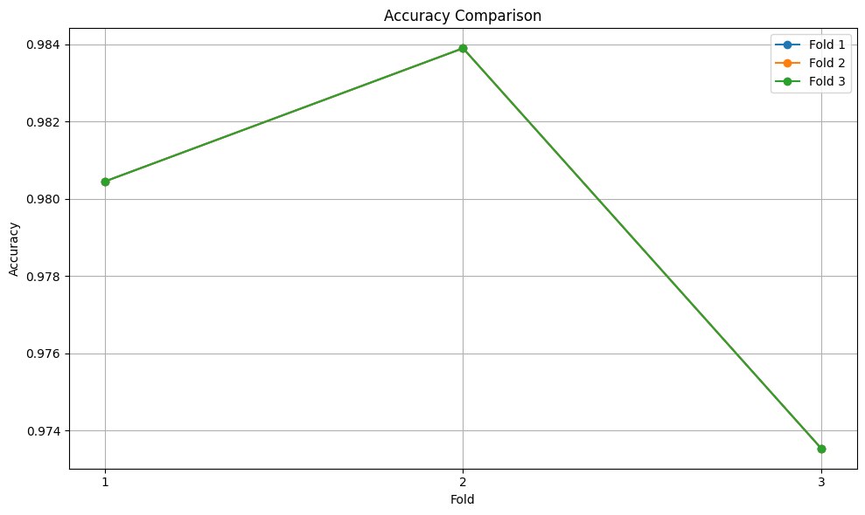
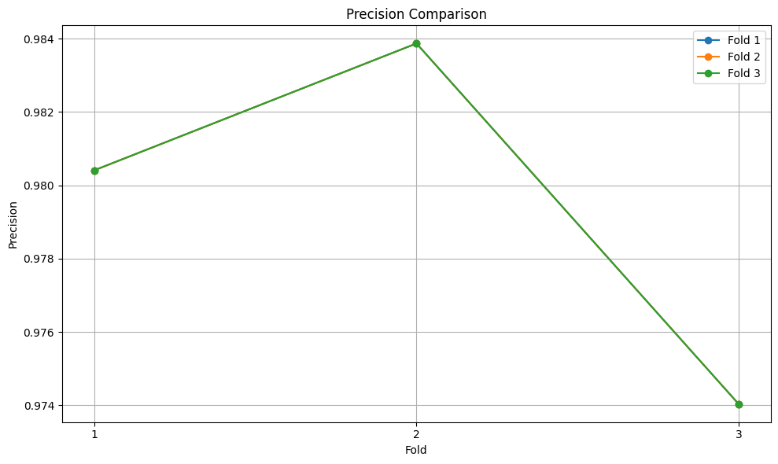
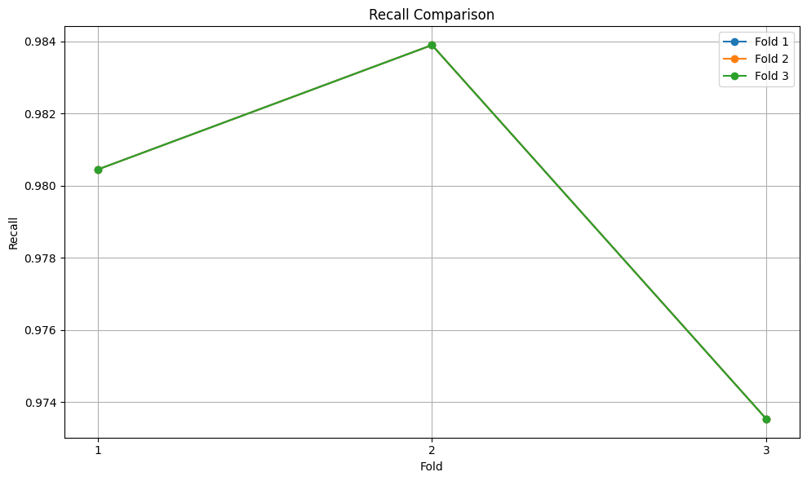
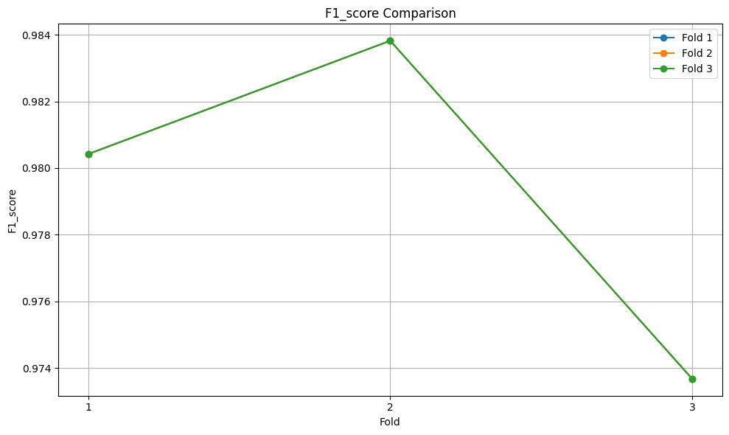
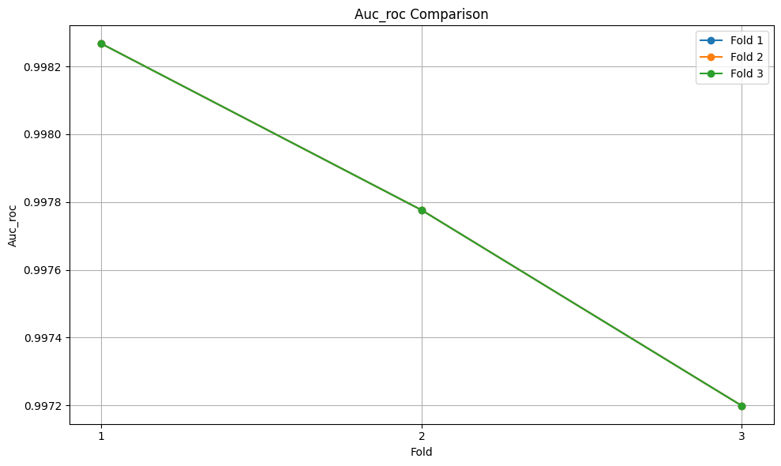

Learning Rate: 0.001
Model Used: MobileNetV3Binary
Execution Time (seconds): 1466.0944702625275
Final Validation Accuracy: 98.10126582278481
Test Accuracy: 0.8493589743589743
Test Precision: 0.8096234309623431
Test Recall: 0.9923076923076923
Test F1-score: 0.8917050691244239
Test AUC-ROC: 0.8017094017094017
Hardware Profile:
Platform: Windows-11-10.0.22631-SP0
Processor: AMD64 Family 25 Model 33 Stepping 0, AuthenticAMD
RAM: 31.93 GB
CUDA Available: True
CUDA Device Count: 1
CUDA Device Name: NVIDIA GeForce RTX 3070

